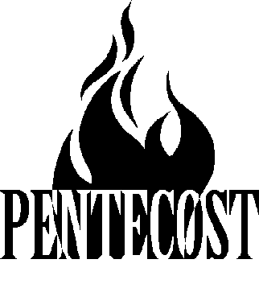The Festival of Pentecost May 28, 2023

Morrison Zion Evangelical Lutheran Church

Wisconsin Evangelical Lutheran Synod

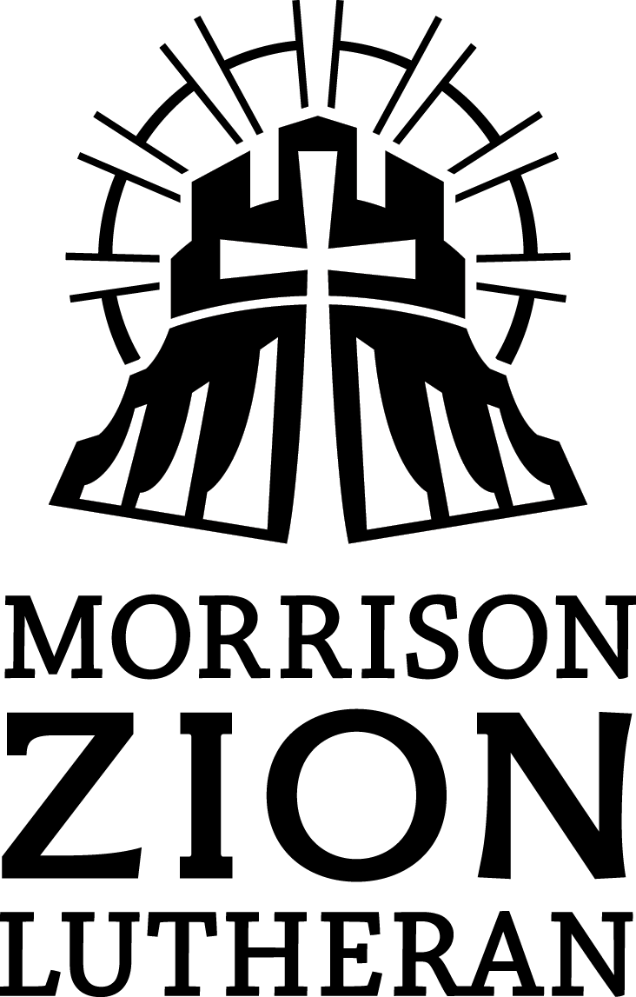

Our mission is to
Glorify God
as we
Gather
around the Gospel
to help people
Grow
in the Gospel
and
Go
with the Gospel

Welcome! We thank God that you have joined us at worship today.
Restrooms are located in the basement. Hearing loop headphones and Large Print Hymnals are available from an usher.
If your children need to leave worship, please take them to the basement. A TV broadcasts the service in the basement.
Today we gather together in the presence of God. He is present among us in a special way through his Word and Sacrament. We acknowledge our sin and rejoice in the good news of forgiveness through the life and death of Christ. This is the focus of our worship.

God’s Old Testament people celebrated the gathering of the harvest at the Festival of Weeks. On the fiftieth day, God sent the promised Counselor on the day we call “Pentecost” This day marked the birthday of the New Testament Church and celebrates the harvest of souls won by the Son and gathered by his servants empowered by his Spirit. Pentecost is the third great festival of the Church and has been commemorated since at least 217 A.D. The Church dresses in red to remind us of the tongues of fire that marked the Spirit’s gift and the blood of the martyrs which was the seed of the Church.

Gathering Rite

Stand

(sing) From all that dwell below the skies
Let the Creator's praise arise.
Alleluia! Alleluia!
Let the Redeemer's name be sung
Through ev’ry land, by ev’ry tongue.
Alleluia! Alleluia! Alleluia! Alleluia! Alleluia!

M: O God, you sent your Holy Spirit to kindle faith and ignite the continuous proclamation of the Gospel for all people, spanning the breadth of time and space.

C: Pour out your Spirit upon us, we pray.

M: By your Holy Spirit increase our commitment to be faith-filled followers of the risen Christ,

C: Pour out your Spirit upon us, we pray.

M: Shape the Church’s speech and song, that she may continually bear witness to the truth.

C: Pour out your Spirit upon us, we pray.

M: Heavenly Father, through Baptism, you engraft us into the Body of Christ, beginning, nourishing, and sustaining our God-given faith.

C: Pour out your Spirit upon us, we pray.

M: May the witness of our lips and our lives give you, Lord, all glory, laud, and praise. Bring us to everlasting life, where with all the saints, angels, martyrs, and apostles, we will join the
heavenly host, magnifying your holy name, Father, Son, and Holy Spirit.
(sing) All praise to God the Father be,
All praise, eternal Son, to Thee;
Alleluia! Alleluia!
Whom with Spirit we adore
Forever and forevermore.
Alleluia! Alleluia! Alleluia! Alleluia! Alleluia!

CONFESSION AND ABSOLUTION

M: We come into the very presence of God, taking spiritual inventory, silently confessing our sins before God.

Silence for personal reflection

Through St. Paul, God exhorts us to “confess our sins to one another, forgiving one another, as God, in Christ, has forgiven us.”

C: I confess to Almighty God, before the whole company of heaven, and to you, my brothers and sisters, that I have sinned in thought, word, and deed by my fault, by my own fault, by my own grievous fault, therefore I pray Almighty God to have mercy on me, forgive me all my sins, and bring me to everlasting life.

M: The almighty God has been merciful to us and has sent his Son to die for all. For his sake he forgives us our sins and calls us from darkness to his marvelous light. Therefore, as a called servant of Christ and by his authority, I forgive you all your sins in the name of the Father and of the Son and of the Holy Spirit.

C: Amen.

M: The almighty and merciful Lord has granted us pardon and peace, and will bring us to life everlasting.

C: Pour out your Spirit upon us, we pray.

(sing) Eternal are your mercies, Lord;
Eternal is your glorious Word.
Alleluia! Alleluia!
Your praise shall sound from shore to shore
Till suns shall rise and set no more.
Alleluia! Alleluia! Alleluia! Alleluia! Alleluia!

Prayer of the Day
M: Let us pray.
Holy Spirit, God and Lord, come to us this joyful day with your sevenfold gift of grace. Rekindle in our hearts the holy fire of your love that in a true and living faith we may tell abroad the glory of our Savior, Jesus Christ, who lives and reigns with you and the Father, one God, now and forever.

C: Amen.

Be seated

The Word

Choir By Faith

First Lesson: Joel 2:28-29
In the Old Testament God poured out his Spirit on the prophets and so revealed his will though visions and dreams. In Numbers 11, God anointed the 70 elders with his Spirit so that they prophesied. When Moses’ young aide loyally objected to some of the elders prophesying in the camp, Moses said, “I wish that all the LORD’s people were prophets and that the LORD would put his Spirit on them!” The prophet Joel said that one day, Moses’ wish would be fulfilled. But when? “Afterward,” in the Messianic age, in the last age of the earth that began on the day God kept the promise of Joel and the wish of Moses and put his Spirit on all his people.
²⁸ “And afterward,
I will pour out my Spirit on all people.
Your sons and daughters will prophesy,
your old men will dream dreams,
your young men will see visions.
²⁹ Even on my servants, both men and women,
I will pour out my Spirit in those days. (NIV)

Psalm of the Day: Psalm 51b
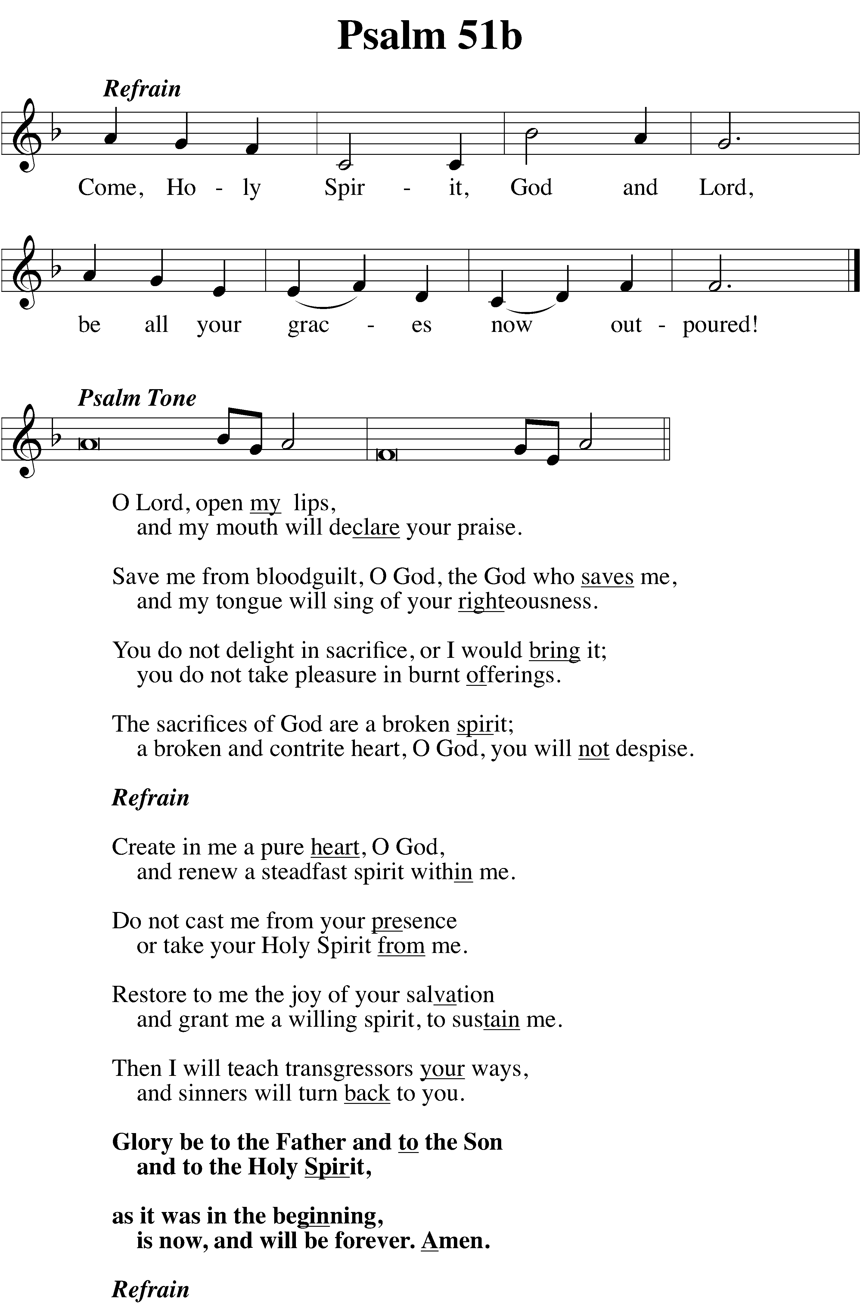

Second Lesson Acts 2:1-21
The Church follows in the footsteps of Christ who was prepared for his ministry by a dramatic, visible outpouring of the Spirit at his baptism. Jesus kept his promise to baptize them with the Holy Spirit and with fire. The real miracle of Pentecost is the transformative gift of the Holy Spirit, taking timid followers of Jesus and making them bold witnesses who carried the Gospel to the world. The sound of the violent wind served as a sign, but was not the gift. The tongues of fire marked its arrival, but they were not the gift. Miraculously speaking in foreign languages was a result, but it was not the gift. “All of them were filled with the Holy Spirit.” Moses wished it; Joel foretold it; the disciples lived it. The sin that had scattered mankind at Babel had been atoned. The last age of the earth (vv 19-21) wouldn’t be marked by the dividing of the peoples, but by their uniting into the Church of Christ where there is neither Jew nor Greek, slave nor free, male nor female.
2 When the day of Pentecost came, they were all together in one place. ² Suddenly a sound like the blowing of a violent wind came from heaven and filled the whole house where they were sitting. ³ They saw what seemed to be tongues of fire that separated and came to rest on each of them. ⁴ All of them were filled with the Holy Spirit and began to speak in other tongues as the Spirit enabled them.
⁵ Now there were staying in Jerusalem God-fearing Jews from every nation under heaven. ⁶ When they heard this sound, a crowd came together in bewilderment, because each one heard their own language being spoken. ⁷ Utterly amazed, they asked: “Aren’t all these who are speaking Galileans? ⁸ Then how is it that each of us hears them in our native language? ⁹ Parthians, Medes and Elamites; residents of Mesopotamia, Judea and Cappadocia, Pontus and Asia, ¹⁰ Phrygia and Pamphylia, Egypt and the parts of Libya near Cyrene; visitors from Rome ¹¹ (both Jews and converts to Judaism); Cretans and Arabs—we hear them declaring the wonders of God in our own tongues!” ¹² Amazed and perplexed, they asked one another, “What does this mean?”
¹³ Some, however, made fun of them and said, “They have had too much wine.”
¹⁴ Then Peter stood up with the Eleven, raised his voice and addressed the crowd: “Fellow Jews and all of you who live in Jerusalem, let me explain this to you; listen carefully to what I say. ¹⁵ These people are not drunk, as you suppose. It’s only nine in the morning! ¹⁶ No, this is what was spoken by the prophet Joel:
¹⁷ “‘In the last days, God says,
I will pour out my Spirit on all people.
Your sons and daughters will prophesy,
your young men will see visions,
your old men will dream dreams.
¹⁸ Even on my servants, both men and women,
I will pour out my Spirit in those days,
and they will prophesy.
¹⁹ I will show wonders in the heavens above
and signs on the earth below,
blood and fire and billows of smoke.
²⁰ The sun will be turned to darkness
and the moon to blood
before the coming of the great and glorious day of the Lord.
²¹ And everyone who calls
on the name of the Lord will be saved.’”[Joel 2:28-32] (NIV)

Verse of the Day: Choir The Day of Pentecost

Stand

Gospel: John 16:5-11
How could Jesus’ departure be advantageous for the disciples? Only when Jesus had finished his redemptive work and returned to the Father would he send the Counselor. At Pentecost, the Holy Spirit fulfilled this promise of Jesus as the Counselor who would work on the world by dwelling in his disciples. His great work is to convict the world in regard to sin, righteousness and judgment. As the Holy Spirit prompted the disciples to preach the Gospel, both believers and unbelievers heard and were convicted in regard to sin—resulting in either repentance or obduracy. The Holy Spirit convicts the world in regard to righteousness, because the purchase price for righteousness had now been paid, (“I am going to the Father”), and the world would either receive it by faith or reject it in unbelief. The Holy Spirit convicts the world in regard to judgment, because although the world has not yet been judged, its ruler has (Revelation 20). The preaching of the Gospel never leaves hearts the same: by either quickening or hardening, the Spirit convicts mankind..
⁵ But now I am going to him who sent me. None of you asks me, ‘Where are you going? ⁶ Rather, you are filled with grief because I have said these things. ⁷ But very truly I tell you, it is for your good that I am going away. Unless I go away, the Advocate will not come to you; but if I go, I will send him to you. ⁸ When he comes, he will prove the world to be in the wrong about sin and righteousness and judgment: ⁹ about sin, because people do not believe in me; ¹⁰ about righteousness, because I am going to the Father, where you can see me no longer; ¹¹ and about judgment, because the prince of this world now stands condemned. (NIV)

M: This is the Gospel of the Lord.

C: Praise be to you, O Christ!

Be Seated

Hymn of the Day Come, Holy Ghost, God and Lord Hymn 176
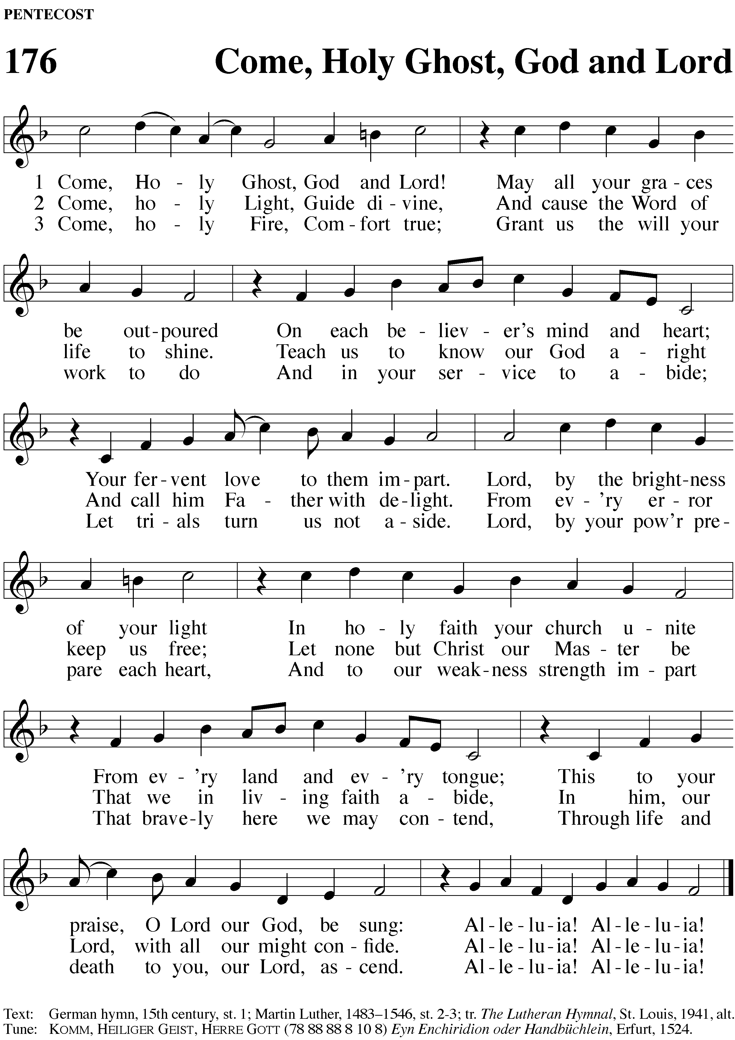

Sermon Rejoice in Your Loss and Gain John 16:5-11

Stand

Prayer of the Church
M: Praise to you, Holy Spirit. We worship and glorify you as the Lord and the giver of life. As you were present at the beginning of the world to shed life on all created things, as you gave a new life of understanding to the disciples in your Pentecost baptism of fire, so by the baptism of water with the Word, you have made the light of faith shine in our hearts to know Jesus as our Lord.
In thanksgiving for your gifts to us, we confess:
C: I believe that I cannot by my own thinking or choosing believe in Jesus Christ, my Lord, or come to him.
But the Holy Spirit has called me by the gospel, enlightened me with his gifts, sanctified and kept me in the true faith. In the same way he calls, gathers, enlightens, and sanctifies the whole Christian Church on earth, and keeps it with Jesus Christ in the one true faith.
M: Holy Spirit, all-seeing Counselor and fountain of all spiritual gifts, stand by us in the weakness of our sinful flesh. Grant us a right understanding of the truths that Jesus taught. Give us strength to endure with patience whatever afflictions God may send into our lives. Help us, intercede for us, train us that we may pray to the Father with boldness and confidence. Preserve us by the power of your Word in our most holy faith as members of the Church, the body of Jesus, where there is forgiveness for all.
C: In this Christian Church he daily and fully forgives all sins to me and all believers.
M: Holy Spirit, highest comfort in every need, in these gray and last days of the world, strengthen our feeble hands, steady our weak knees, encourage our fearful hearts. Remind us of your Word and promises: “Be strong; do not fear. Your Lord will come again. He will come to save you.” And in your final, mighty, creative act, O Holy Spirit, raise up our bodies so that we, together with all the saints, may lift up our heads and with glorified eyes see our Savior drawing near.
C: On the Last Day he will raise me and all the dead and give eternal life to me and all believers in Christ. This is most certainly true. Amen.
© 1999 Northwestern Publishing House. Reprinted by permission.

Lord’s Prayer
Our Father, who art in heaven, hallowed be thy name, thy kingdom come, thy will be done on earth as it is in heaven. Give us this day our daily bread; and forgive us our trespasses, as we forgive those who trespass against us; and lead us not into temptation, but deliver us from evil. For thine is the kingdom and the power and the glory forever and ever. Amen.

THE SACRAMENT
M: The Lord be with you.
C: And also with you.
M: Lift up your hearts.
C: We lift them up unto the Lord.
M: Let us give thanks to the Lord, our God.
C: It is good and right so to do.

Proper Preface
M: It is truly good and right that we should at all times and in all places give you thanks, O Lord, holy Father, almighty and everlasting God, through Jesus Christ, our Lord, who on this day kept his promise and poured out the Holy Spirit to empower his church to proclaim the gospel in all the world. Therefore, with all the saints on earth and hosts of heaven, we praise your holy name and join their glorious song:

Holy, Holy, Holy

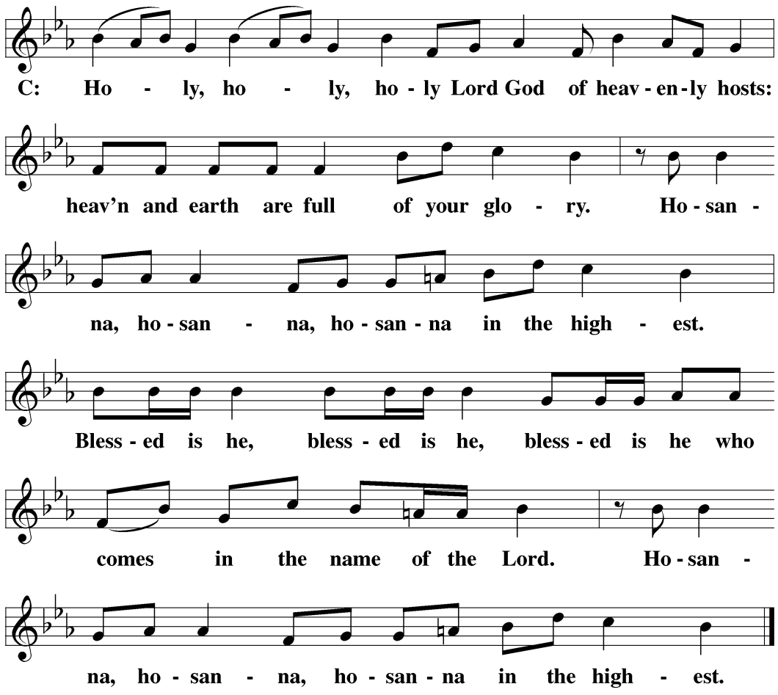

Words of Institution
M: Our Lord Jesus Christ, on the night he was betrayed, took bread; and when he had given thanks, he broke it and gave it to his disciples, saying, “Take and eat; this is my body, which is given for you. Do this in remembrance of me.”

Then he took the cup, gave thanks, and gave it to them saying, “Drink from it, all of you; this is my blood of the new covenant, which is poured out for you for the forgiveness of sins. Do this, whenever you drink it, in remembrance of me.”

M: The peace of the Lord be with you always.

C: Amen.

Be Seated

Distribution

Hymn O Spirit of Life, O Spirit of God CW 186
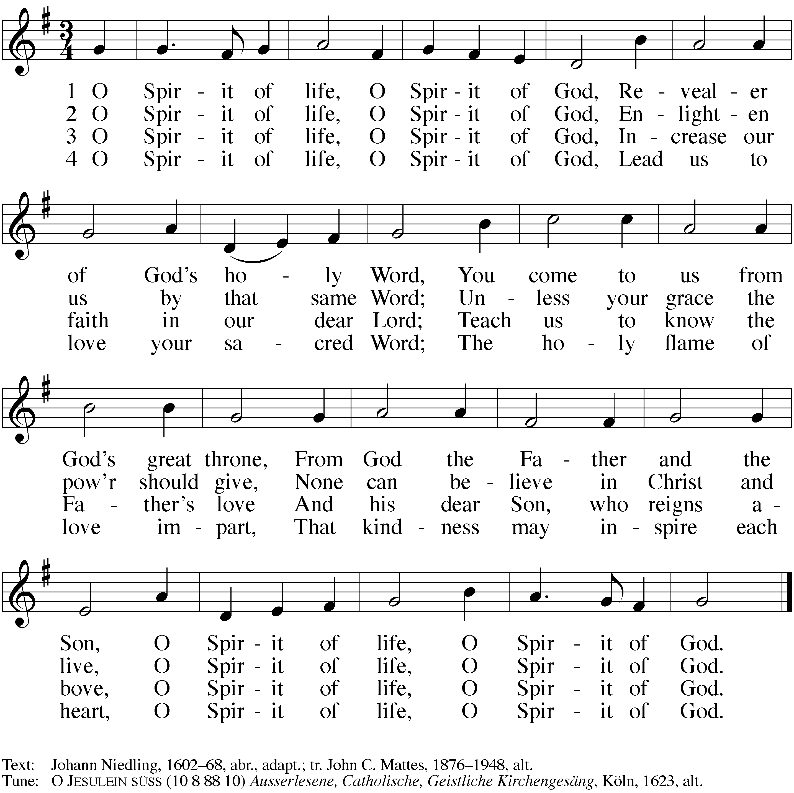

THANKSGIVING

Stand

Song of Simeon
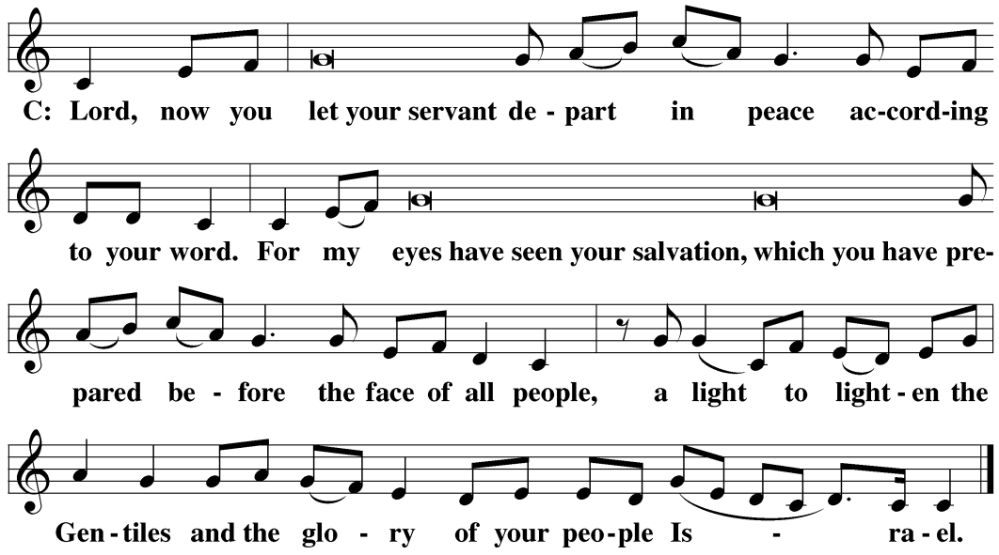

M: We give thanks, almighty God, that you have refreshed us with this holy supper. We pray that through it you will strengthen our faith in you and increase our love for one another. We ask this in the name of Jesus Christ, our Lord, who lives and reigns with you and the Holy Spirit, one God, now and forever.

C: Amen.

Benediction
M: The Lord bless you and keep you.
The Lord make his face shine on you and be gracious to you.
The Lord look on you with favor and give you peace.

C: Amen.

Be seated

Closing Hymn: God Has Spoken by His Prophets Hymn 281:3
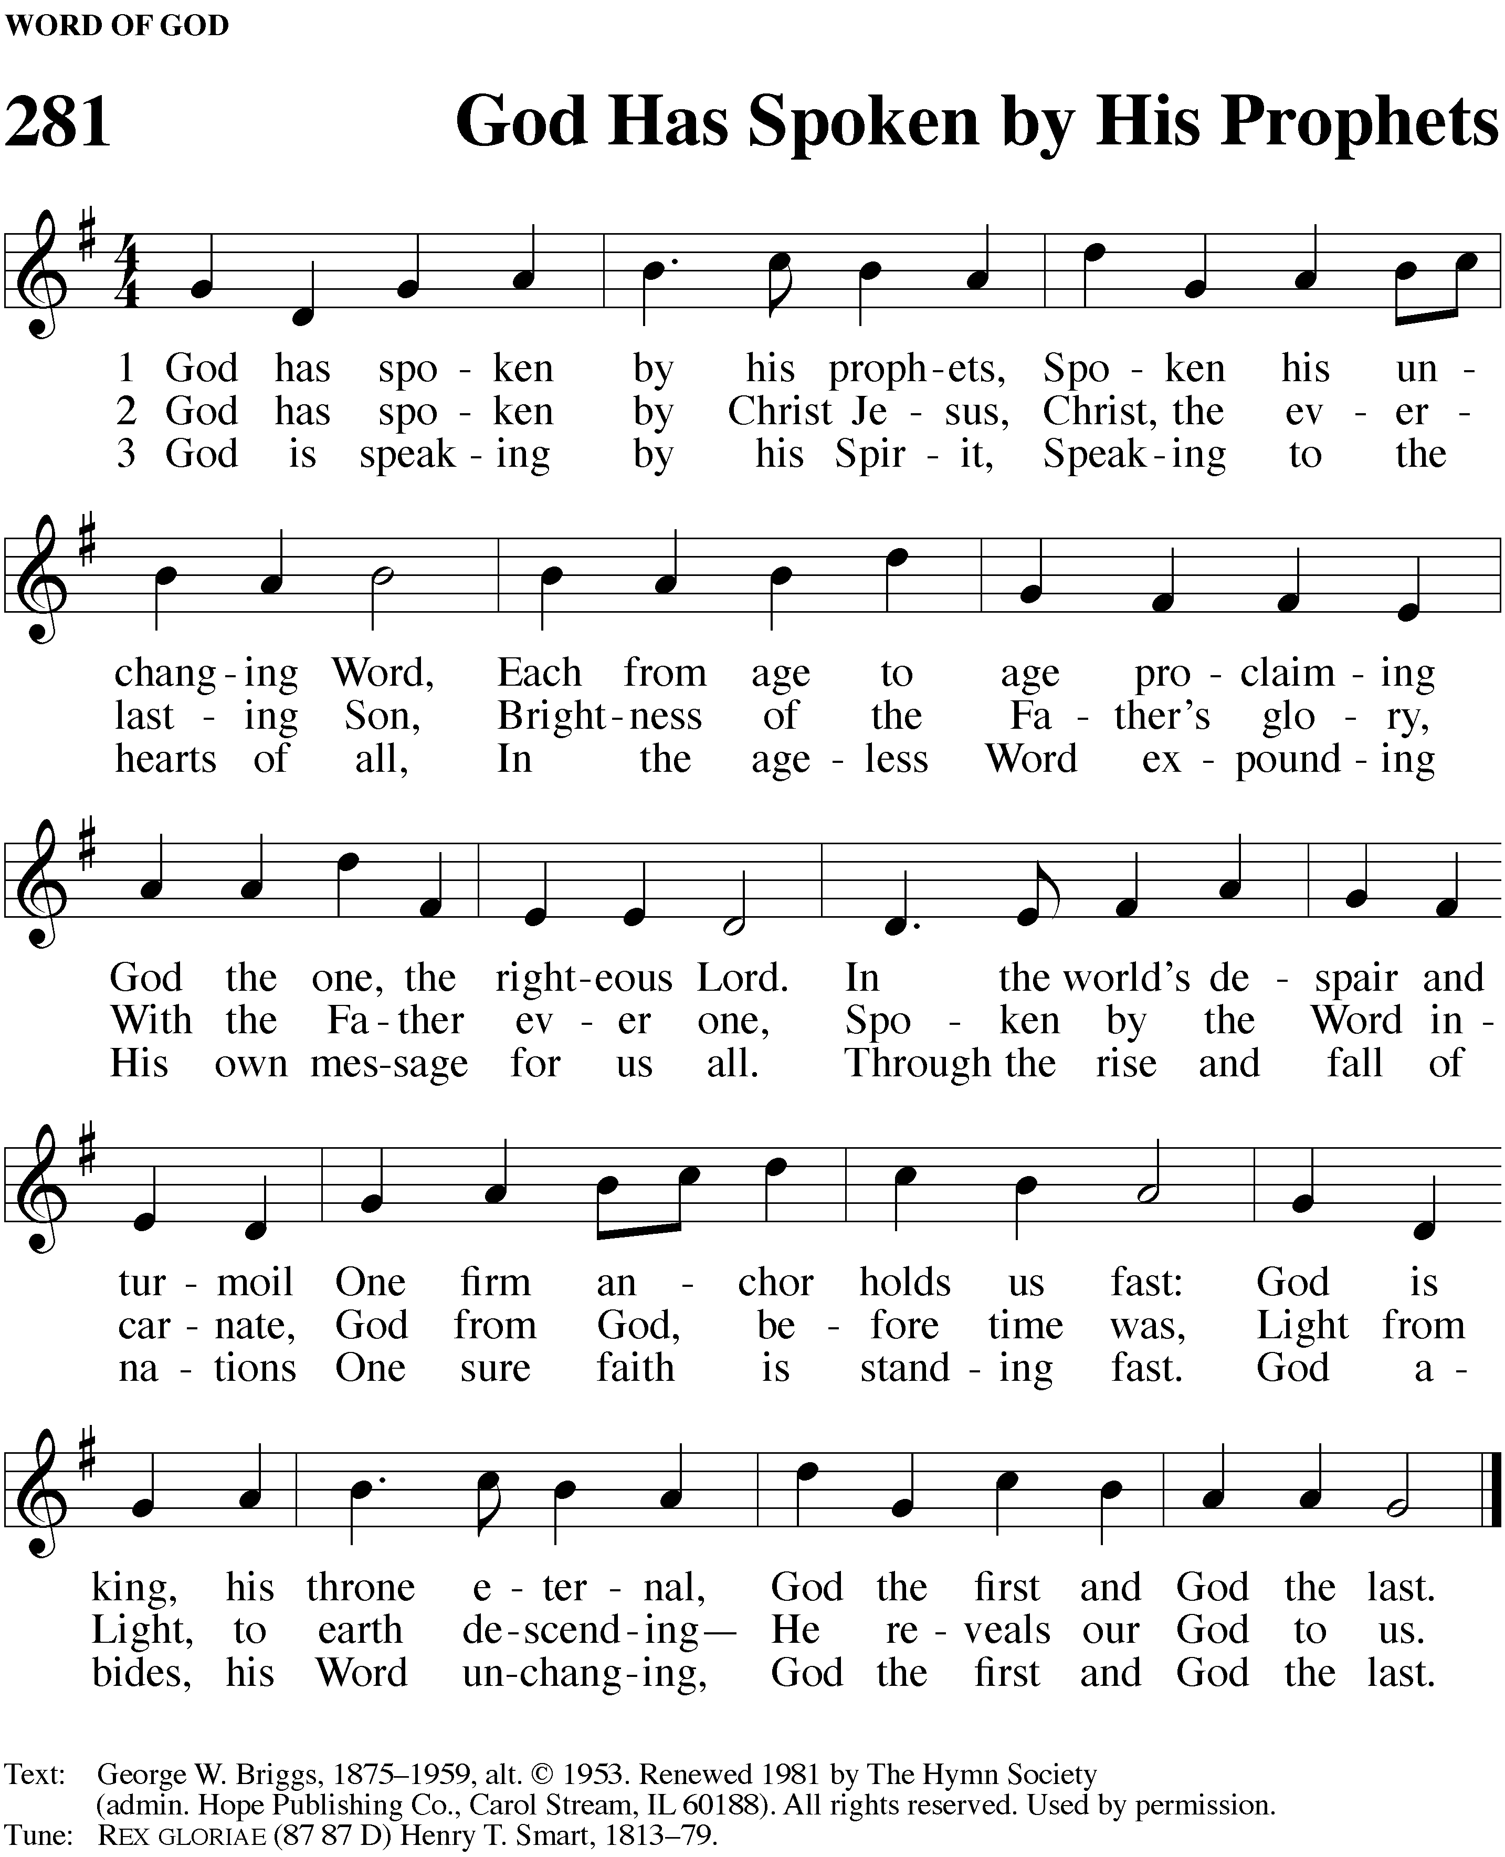

OneLicense.net License #A-725297

